ECPRD Seminar
Chamber of Deputies
Rome, 12-13/06/2014

HOTEL BOOKING FORM
To be sent directly to the hotel

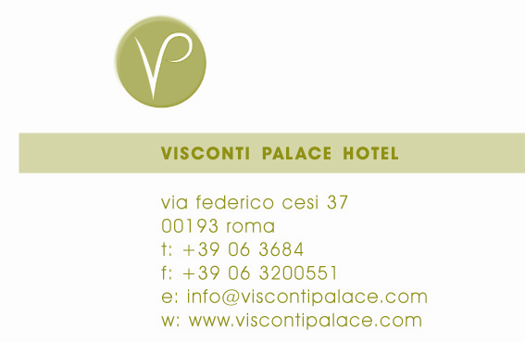
Reservations Department
Via Federico Cesi, 37
I-00193 Roma
Reservation office Tel. +39-06-3684847 – fax +39-06-3684844
E-mail: mice@viscontipalace.com

IMPORTANT
Please make your reservation directly with the hotel Reservations Department by sending this form via fax or e-mail. Full details of credit card are required along with this form in order to guarantee/secure the reservation.The cancellation policy is 48 hours prior to the arrival.

Name ____________________________________________________

Address ____________________________________________________

Telephone no. _________________________ Fax no.____________________

Email address ____________________________________________________

Name of accomp. person ____________________________________________________

¦ Superior double use single room at € 189,00/per room per night, Buffet breakfast and Vat included
¦ Superior double room at € 230,00 / per room per night, Buffet breakfast and Vat included
¦ Premier double use single room at € 212,00/per room per night, Buffet breakfast and Vat included
¦ Premier double room at € 260,00 / per room per night, Buffet breakfast and Vat included

The Rome City tax Equal to Euro 3,00 per person, daily is NOT included

Arrival on: Departure on:

PAYMENT INFORMATION
I guarantee my arrival and the payment of my account at the Hotel with the following credit card:

Credit Card: American Express Diners Club Master Card VISA

Credit Card Number Expiration Date

Name of Credit Card Holder

PAYMENT AND CANCELLATION POLICY:

- Credit card will be used as guarantee of reservation, payment will be done during departure at check out time
- Cancellation is possible within 48 hours before arrival, after that deadline one night penalty will be charged on the provided credit card

